- Sign In and Set Up
- Meeting Controls
- Some Resources
Getting Started:
Visit the Tulane Zoom web page at: Tulane.zoom.us, choose “Tulane Account Login”, and enter your Tulane ID and password.

Sign In and Set Up
Zoom Web Portal:
Go to Tulane.zoom.us and click the button labeled Sign In. Enter your email address and password. Upon sign in, you will be taken to your Profile page.

Zoom Desktop Client:
- Once the Zoom Client for Meetings is installed, click the Sign In button (use the “Sign In with SSO” option to reach the Tulane Sign-in page).
- Enter in your User Name and password on the login screen

Zoom Mobile App Setup (Android/IOS)
- Download Zoom Cloud Meetings app (available on Google Play-store)
- Go to Sign-in > select the SSO option > type in “Tulane” and then press enter.
- You will be redirected to enter in your Tulane credentials from the Tulane login page
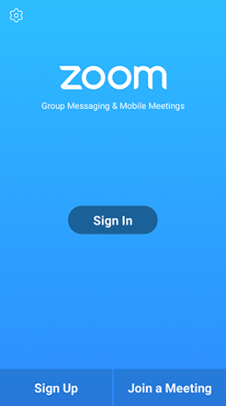
**If SSO (Single Sign-On) doesn’t work or you are having issues. Tap “Join a Meeting” if you want to join without signing in
. If you are successful at signing in to Zoom then tap Join.
- Enter your display name and the meeting ID number you received in your email invitation.
  - If you're signed in, change your name if you don't want your default name to appear.
  - If you're not signed in, enter a display name.
- Select if you would like to connect audio and/or video and tap Join Meeting.
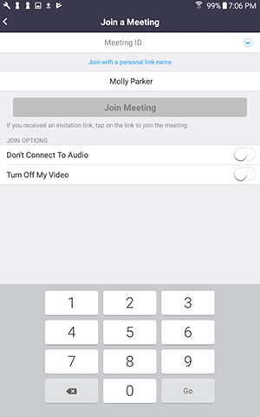
Meeting Controls
Audio
When starting/joining a meeting, you can join the audio by phone or computer.
- Choose “Join Audio by Computer” to connect your computers mic and speakers to the Zoom Meeting. You can test your Audio sources by using the “Test Computer Audio” link when joining.
- Choose “Phone Call” and dial the number provided. Enter the Meeting ID and make sure to input the “Participant ID”
*Tip: Clicking on the Mic icon will let you mute and unmute your audio once connected

Video
- Access Video settings before or during a meeting by clicking on the “Settings” icon on your Zoom Desktop Application.
- On the Video tab you can preview and change your camera source via the down arrow. (Virtual Background)
- Clicking on the Video icon will let you start and stop your video feed
Chat
- Click “Chat” to start an in meeting message with participants in the meeting
- The dropdown on the chat window will allow you to message Everyone, or a specific participant
Mobile Meeting Controls
The host controls will appear at the bottom of your screen, except for End Meeting with appears at the top of your screen, next to the Meeting ID.
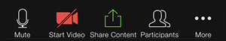

Some Resources
You can access Getting Started Videos and join weekly Zoom training directly from the experts at Zoom.
A link to Zoom’s Help Center is available using the Support link at the bottom of the Tulane Zoom Help Center link at the top of each page of the web portal.

